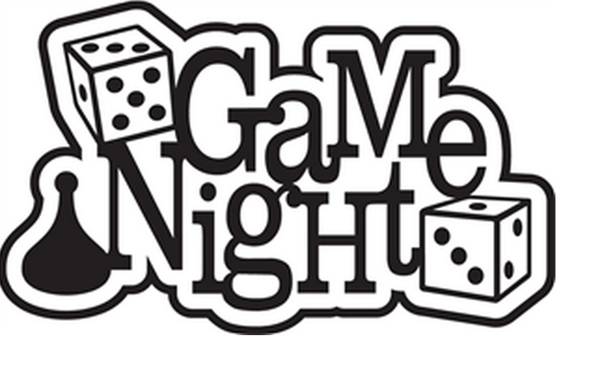

**Free food for all engineers!!**

**BEC 355**

**5:00-6:30 pm**

**Wednesday Jan. 28, 2015**

* **Candy Land**
* **Scrabble**
* **Apples to Apples**
* **Phase Ten**
* **Scattergories**
* **Or bring your own!**

**Hosted by UAB Engineering Mentors**